Excel Assignment - 17

1. What are modules in VBA and describe in detail the importance of

creating a module?

A VBA module is used to store any VBA code that you have written in the VBE (Visual Basic Editor).

The modules are contained within a VBA Project and when the file is saved – be it an Excel workbook, Word document or Access database, the module or modules are saved within that file – that file is essentially the parent application of the module.

Modules can also be exported out of the parent file and saved as their own individual files.  This is useful when you want to re-use code in a different file, and therefore perhaps import that module into a new file.

**Type of modules**

The modules are organised into 3 different types.

1. **Standard modules** – most of your code will go into this type of module. When you record a macro, it gets put into a standard module.    When you write a general procedure to be used throughout your workbook, it also normally goes into a standard module.
2. **Object** **modules** – these type of modules hold the code the is unique to that individual workbook or worksheet. Most of the code in these type of modules are known as **EVENTS**.   An event can occur when a workbook is opened or closed for example, or when a sheet is clicked (the **Click Event**),. The module can also contain code that is written by yourself and used by the events.  The module behind a custom form that you create is also an Object module.
3. **Class modules** – this module is used to create objects at run time. Class module are used by Advanced VBA programmers and will be covered at a later stage.

When your write your VBA code, you will usually use more than one module.  It is good coding practice to ‘group’ your code into relevant modules – for example put all the global variables in one module, all public functions in another module etc.

2. What is Class Module and what is the difference between a Class

Module and a Module?

A class module is **a group of code that allows you to create objects and utililise them in your application**.

In class module Public variables in a class module can only be accessed if we have an object variable containing a reference to a particular instance of a class

And in standard module Variable declared public in a standard module are visible from anywhere in our project.

3. What are Procedures? What is a Function Procedure and a Property

Procedure?

A procedure **tells the application how to perform a specific task**. Use procedures to divide complex code tasks into more manageable units. Open the module for which you want to write the procedure.

A Function procedure is a series of Visual Basic statements enclosed by the Function and End Function statements. The Function procedure performs a task and then returns control to the calling code. When it returns control, it also returns a value to the calling code.

A property procedure is a series of Visual Basic statements that manipulate a custom property on a module, class, or structure. Property procedures are also known as property accessors.

4. What is a sub procedure and what are all the parts of a sub procedure

and when are they used?

A Sub procedure is a series of Visual Basic statements enclosed by the Sub and End Sub statements that performs actions but doesn't return a value. A Sub procedure can take arguments, such as constants, variables, or expressions that are passed by a calling procedure.

A Sub procedure is a series of Visual Basic statements enclosed by the Sub and End Sub statements that **performs actions but doesn't return a value**. A Sub procedure can take arguments, such as constants, variables, or expressions that are passed by a calling procedure.

5. How do you add comments in a VBA code? How do you add multiple

lines of comments in a VBA code?

* First, click on the line where you want to insert the comment.
* After that, type an APOSTROPHE using your keyboard key.
* Next, type the comment that you want to add to the code.
* In the end, hit enter to move to the new line and the comment will turn green

The easiest way is to select all the lines and then use the comment button from the toolbar or you can also add an APOSTROPHE at the starting of each line.

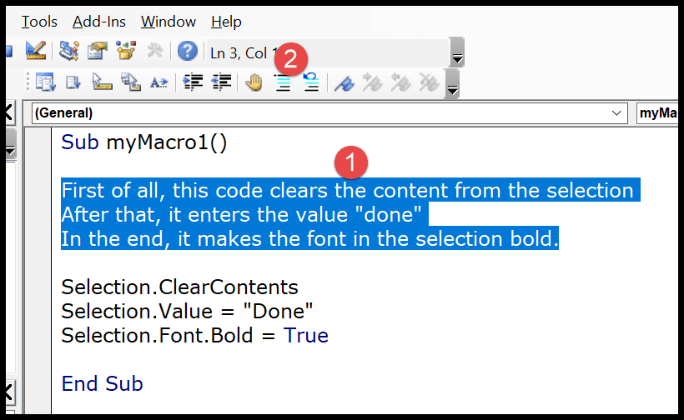

## The moment you click the comment button it will convert all the lines into a multi-line comment block. Shortcut Key for Add a Comment

## First of all, right-click on the toolbar and then click on the customize option.

* 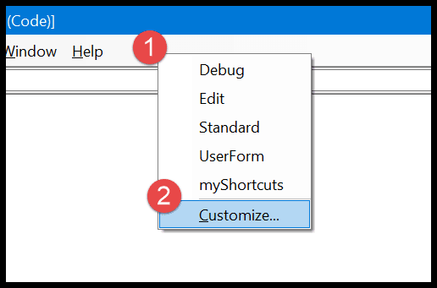
* In the customize dialog box, go to the Command-Tab ➜ Edit ➜ select the comment block, and drag it to the toolbar.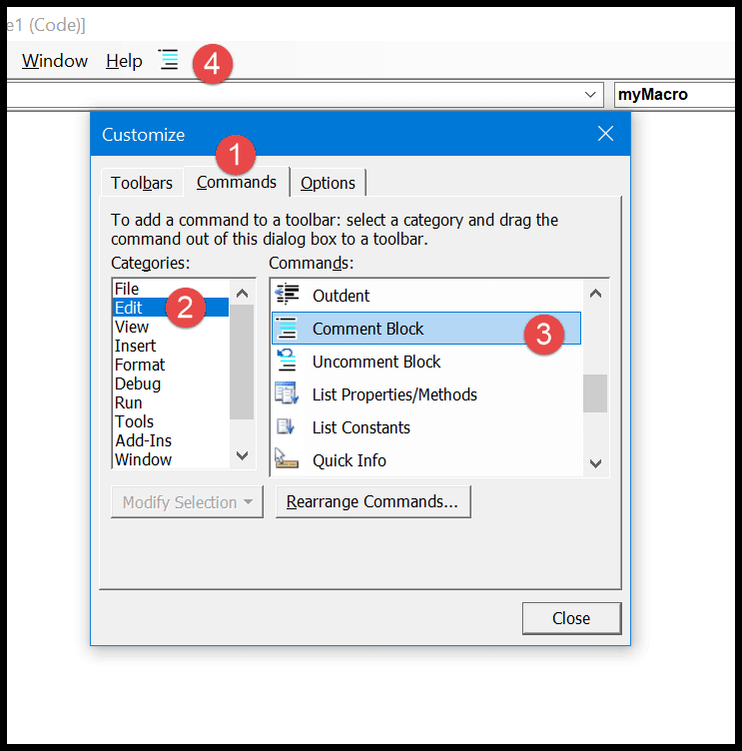
* After that select the comment block icon, like below and right-click on it, and then enter “&” before the name. So it should be like “&Comment Button”.
* 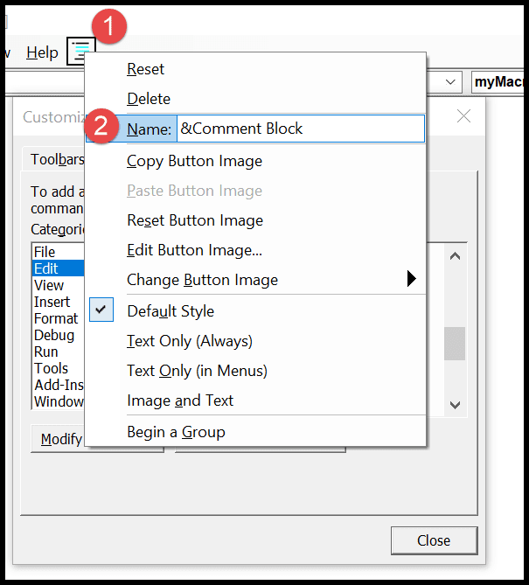
* Now, again right-click on the button and select the “Image and Text” and after that come back to the visual basic editor.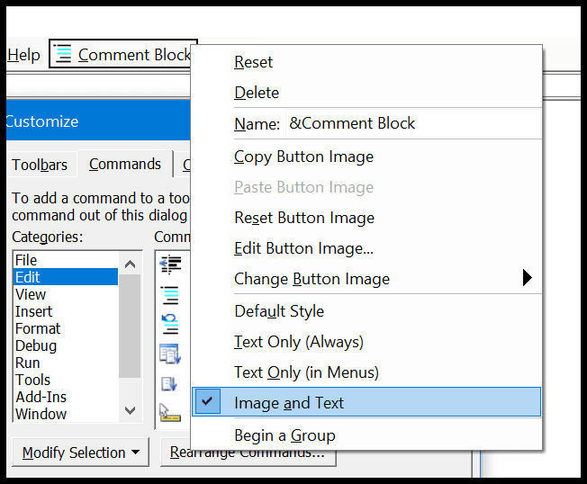

Now you can convert a line into a comment by using the **shortcut key Alt + C**.

And if you want to create a shortcut key for the uncomment button you can simply use the above steps to add the uncomment button to the toolbar and the shortcut key for it will be Alt + U.